Multiple-choice section

|  |  |  |  |  |  |  |  |  |  |
| --- | --- | --- | --- | --- | --- | --- | --- | --- | --- |
| Question | 1 | 2 | 3 | 4 | 5 | 6 | 7 | 8 | 9 |
| Answer | D | C | A | B | D | B | B | D | C |

Question 1 [2.6] [10A]

D

10A: mean =  10B: mean = 

10A: 55 56 67 67 78 78 83 88 88 98

IQR = 88 − 67 = 21

10B: 50 52 58 58 60 66 72 80 80 97

IQR = 80 − 58 = 22

Difference in means is 8.5. Difference in IQR is 1.

Question 2 [2.3]

**C**

As the maximum temperature reached may not have occurred at one of the times when the measurements were recorded you cannot say with any certainty what that value would have been.

Question 3 [2.5]

**A**

QL = 1.5, median = 3 and QU = 5

Question 4 [2.2]

B

The relationship is negative as the points fall from top left to bottom right. They are slightly scattered so we would say a moderately strong negative linear relationship.

Question 5 [2.2]

D

IQR = 25 − 17 = 8

1.5 × IQR = 12

QL − 1.5 × IQR = 17 − 12 = 5

QU + 1.5 × IQR = 25 + 12 = 37

Outliers are less than 5 or more than 37.

Question 6 [2.2]

**B**

60% of the data is below approximately 54.

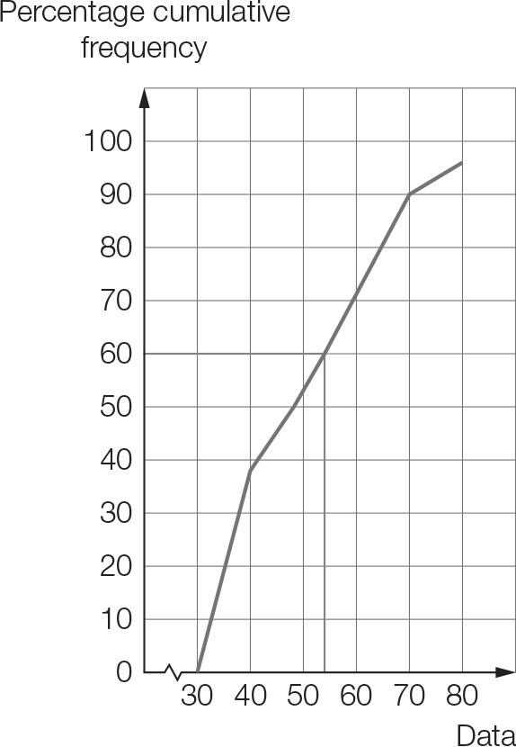

Question 7 [2.1]

**B**

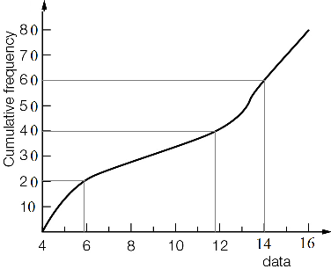

The lower quartile, median and upper quartile are 6, 12, 14.

Question 8 [2.2]

**D**

IQR = 37 − 24 = 13 ∴ **A** is correct

24 is the lower quartile ∴ **B** is correct

About 75% of values lie below the upper quartile, which is 37 ∴ **C** is correct

Question 9 [2.8] [10A]

**C**

Mean ≈ 3.3, standard deviation ≈ 2.87

Multiple-choice total marks: 9

Short answer section

Question 10 2 marks [2.1–2.7]

(a) A cumulative frequency curve can be used to find the five-number summary from a set of continuous data that is presented in grouped form.

(b) An outlier is a value that is significantly lower or higher than the majority of values in a data set.

Question 11 5 marks [2.1]

**(a)** To find a suitable set of numbers it is best to start with dashes to represent each value required. In this case we will try 10 dashes. Then fill in the bits known that are whole numbers.

6 ____ ____ ____ ____ ____ ____ ____ ____ 20

Now, the median is between the fifth and sixth numbers and is 12. We could use a few different number combinations here but the simplest solution is to say they are both 12.

6 ____ ____ ____ 12 12 ____ ____ ____ 20

The lower quartile is the third value so we can fill this in as 9 and the upper quartile is the eighth value and is 15.

6 ____ 9 ____ 12 12 ____ 15 ____ 20

The remaining spaces can be filled in with any values that fit numerically with the pattern.

As an example: 6 **7** 9 **10** 12 12 **13** 15 **18** 20 (The bold values could be different.)

**(b)** The following calculation is for the data set given above. (Students will not necessarily have the same values so this answer could be different.)  
Mean = 

Question 12 7 marks [2.1]

|  |  |  |  |
| --- | --- | --- | --- |
| x | f | x × f | Cumulative  frequency |
| 23 | 8 | 184 | 8 |
| 24 | 10 | 240 | 18 |
| 25 | 3 | 75 | 21 |
| 26 | 4 | 104 | 25 |
| 27 | 1 | 27 | 26 |
| Total | 26 | 630 |  |

(a) Mean =  ( 1 d.p.)

(b) QL is the 7th data value.  
The median is the midpoint of the 13th and 14th data value.  
QU is 20th data value.

|  |  |  |  |  |
| --- | --- | --- | --- | --- |
| Lowest | QL | Median | QU | Highest |
| 23 | 23 | 24 | 25 | 27 |

Question 13 3 marks [2.2]

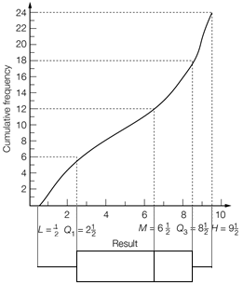

Question 14 5 marks [2.3]

(a) Set A: (i) median = 3 (ii) range = 6 − 1 = 5 (iii) IQR = 4.5 − 2 = 2.5  
Set B: (i) median = 2 (ii) range = 6 − 0 = 6 (iii) IQR = 4 − 0.5 = 3.5

(b) Set A values are higher on average. Set B data is more spread out than Set A. The highest value is in Set A and the lowest value is in Set B.

Question 15 3 marks [2.2]

**(a)**

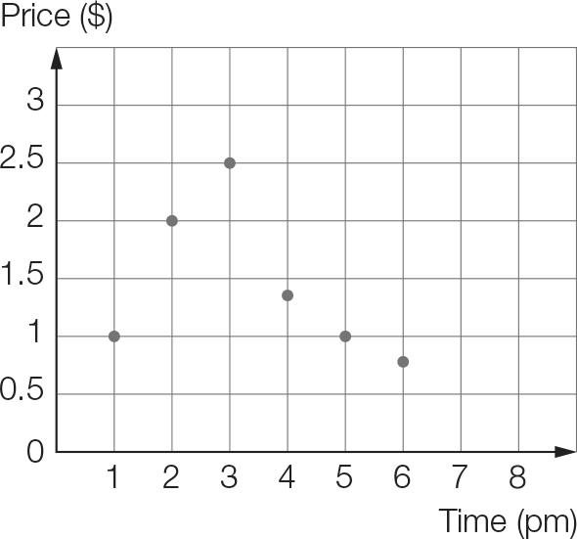

**(b)** At 1 pm the price started at $1 then rose significantly through to 3 pm, where the price had increased by a factor of 2.5. The price then decreased over the next 3 hours, rapidly at first, to slightly below its initial level.

Question 16 10 marks [2.2]

**(a)** Put the data in order as a first step:

1865 1871 1872 1906 1908 1909 1909 1913 1917 1918 1921 1925 1932

1932 1932 1933 1935 1937 1940 1942 1945 1948 1951 1954 1968 1991

lower quartile, QL: 1909 median: 1932 upper quartile, QU: 1942

IQR = 1942 − 1909 = 33 years

**(b)** QL − 1.5 × IQR = 1909 − 1.5 × 33 = 1859.5 QU + 1.5 × IQR = 1942 + 1.5 × 33 = 1991.5

There are no outliers in this data set.

**(c)**

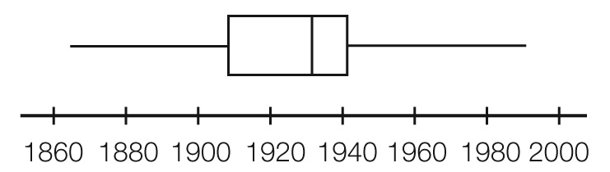

**(d)** The middle 50% occurred between 1909 and 1942.

Question 17 5 marks [2.5]

**(a)** A child under the age of 1 has limited ability and understanding in order to participate in board games or complete jigsaw puzzles. The over 20s probably have less need for toy trains but perhaps are purchasing model trains etc.

**(b)** The number of toys purchased for each age group can be determined by adding up the totals of each of the bars within the group.

20+ : 6 + 11 + 19 + 21 = 57

Teenagers: 5 + 4 + 6 = 15

4-12 years: 4 + 3 + 11 + 32 = 50

1-3 years: 14 + 6 + 17 + 28 = 65

0-12 months: 9 + 2 + 2 + 12 = 25  
The most toys were purchased for 1–3 year olds followed by the 20 and over group. The least number of toys were purchased for teenagers.

**(c)** The number of each toy types can be determined by adding together the totals of the bars in each category.

Trains: 6 + 4 + 14 + 9 = 33

Board games: 11 + 5 + 3 + 6 + 2 = 27

Jigsaws: 19 + 4 + 17 + 11 + 2 = 53

Blocks: 21 + 6 + 32 + 28 + 12 = 99

**(d)** No. The 20+ age group would have a greater population than the 1–3 year population. That is, the 1-3 year population includes all 1, 2 and 3 year old children, whereas the 20+ age group includes all adults aged 20, 21 … 100+ years old. Therefore there could be about 25 times as many people in the older age group.

**(e)** Over the time period, 99 sets of Lego/Duplo were purchased, costing a total of $2757.15.  
Therefore each set has an average value of 2757.15 ÷ 99 = $27.85

Short answer results: ___ / 40

Extended answer section

Question 18 10 marks [2.1]

|  |  |  |  |
| --- | --- | --- | --- |
| Weight (kg) | Frequency | Data  value | Cumulative  frequency |
| <64 | 0 | 64 | 0 |
| 64−<66 | 2 | 66 | 2 |
| 66−<68 | 4 | 68 | 6 |
| 68−<70 | 12 | 70 | 18 |
| 70−<72 | 15 | 72 | 33 |
| 72−<74 | 11 | 74 | 44 |
| 74−<76 | 10 | 76 | 54 |
| 76−<78 | 9 | 78 | 63 |
| 78−<80 | 7 | 80 | 70 |

(a)

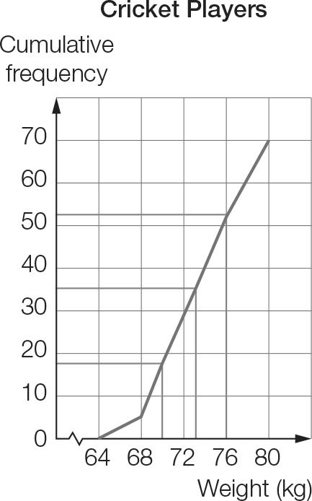

(b) As shown on the graph, the approximate values for the lower quartile is 70, the median is 72 and upper quartile is 76.

(c)

|  |  |  |  |  |
| --- | --- | --- | --- | --- |
| Min | QL | Median | QU | Max |
| 64 | 70 | 72 | 76 | 80 |

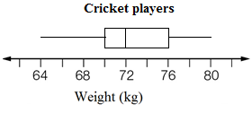

(d) The actual values could have occurred anywhere within the 2 kg class intervals for weights.  
So the minimum value of 64 kg would be in the interval 64–<66 kg.

Question 19 10 marks [2.4, 2.6] [10A]

|  |  |  |  |  |  |  |  |  |
| --- | --- | --- | --- | --- | --- | --- | --- | --- |
| English | 45 | 46 | 30 | 34 | 50 | 44 | 38 | 40 |
| Maths | 27 | 50 | 22 | 28 | 44 | 12 | 44 | 42 |

(a) (i) y = 0.68x + 5.80

(ii)

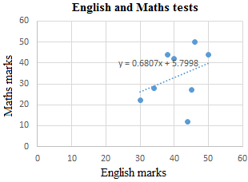

(iii) Maths mark = English mark × 0.68 + 5.80

(iv) Maths mark = 36 × 0.68 + 5.80 = 30.28  
The predicted mark for Maths is 30.

(b) (i) y = 0.17x + 35.10

(ii) English mark = Maths mark × 0.17 + 35.10

(iii) English mark = 40 × 0.17 + 35.10 = 41.90  
The predicted mark for English is 42.

Question 20 15 marks [2.1, 2.3]

Order the data:

City X: 6.8 7.4 7.5 8.6 9.4 10.4 11.6 12.3 14.3 14.3 15.5 15.7

City Y: 4 5.1 5.9 8.2 9.7 12.5 14.8 17.4 17.9 20.2 20.6 21.2

(a) City X: min = 6.8 °C, QL = 8.05 °C, median = 11 °C, QU = 14.3 °C, max = 15.7 °C  
City Y: min = 4 °C, QL = 7.05 °C, median = 13.65 °C, QU = 19.05 °C, max = 21.2 °C

(b)

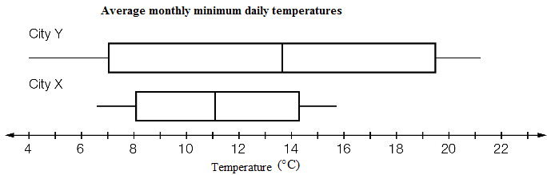

(c) The temperatures for City Y are, on average, higher and more widely spread than for City X.  
City Y has both the lowest temperature and the highest temperature.

Question 21 7 marks [2.1, 2.3]

|  |  |  |  |  |  |  |  |  |  |  |  |  |  |  |  |  |  |  |  |  |  |  |  |  |  |  |  |  |  |  |  |  |  |  |  |  |  |
| --- | --- | --- | --- | --- | --- | --- | --- | --- | --- | --- | --- | --- | --- | --- | --- | --- | --- | --- | --- | --- | --- | --- | --- | --- | --- | --- | --- | --- | --- | --- | --- | --- | --- | --- | --- | --- | --- |
| (a)   |  |  |  | | --- | --- | --- | | x | f | x × f | | 1 | 2 | 2 | | 2 | 3 | 6 | | 3 | 5 | 15 | | 4 | 1 | 4 | | 5 | 2 | 10 | | 6 | 0 | 0 | | 7 | 1 | 7 | | 8 | 2 | 16 | | 9 | 1 | 9 | | 10 | 3 | 30 | | Total | 20 | 99 | | (b) ‘More than half’ is 6–10 games. Number of teams = 0 + 1 + 2 + 1 + 3 = 7 teams Proportion =  = 0.35 35% of winning teams won more than half of their games. |
| Mean =  = 4.95  On average, the winning teams won 5 games.  (c)   |  |  |  | | --- | --- | --- | | x | f | x × f | | 0 | 15 | 0 | | 1 | 2 | 2 | | 2 | 3 | 6 | | 3 | 5 | 15 | | 4 | 1 | 4 | | 5 | 2 | 10 | | 6 | 0 | 0 | | 7 | 1 | 7 | | 8 | 2 | 16 | | 9 | 1 | 9 | | 10 | 3 | 30 | | Total | 35 | 99 | | (d) Proportion =  =  or 0.2  or 20% of all teams won more than half of their games. |

Mean =  = 2.828… ≈ 2.8

On average, the teams won 2.8 games.

Question 22 18 marks [2.3, 2.8]

(a)

|  |  |
| --- | --- |
| Weight (kg) | Frequency |
| 30–<35 | 2 |
| 35–<40 | 7 |
| 40–<45 | 9 |
| 45–<50 | 12 |
| 50–<55 | 7 |
| 55–<60 | 3 |

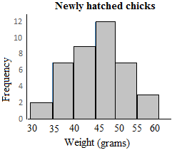

(b) The data in order:  
33 33 37 37 38 38 38 39 39 40 | 40 41 41 42 42 43 43 43 45 45  
45 45 45 45 47 48 48 49 49 49 | 50 51 52 52 52 54 54 55 55 56

|  |  |  |  |  |
| --- | --- | --- | --- | --- |
| Min | QL | Median | QU | Max |
| 33 | 40 | 45 | 49.5 | 56 |

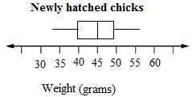

(c)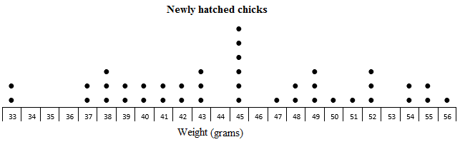

(d) The dot plot has the raw data so you can see exactly how many of each weight. The weights range from 33 g to 56 g with six chicks at 45 g. The histogram shows a symmetrical distribution with a peak in the middle. Weights appear to range from 33 g to 60 g. The box plot shows the weights from 33 g to 56 g with an even spread overall.

[10A] (e) From a calculator (1 d.p.):  
Mean = 45.0 g, SD = 6.1 g

[10A] (f) (These are sample answers; students will almost certainly have different values.)  
14 24 9 11 28 → 52, 54, 49, 38, 52  
27 28 39 18 15 → 38, 52, 41, 33, 52  
4 16 15 24 6 → 54, 55, 52, 43, 56  
30 18 9 40 21 → 45, 33, 49, 49, 40  
2 19 33 4 11 → 45, 37, 38, 54, 40  
27 24 40 26 11 → 38, 43, 49, 50, 38  
Sample 1: 52, 54, 49, 38, 52  
Sample 2: 38, 52, 41, 33, 52  
Sample 3: 54, 55, 52, 43, 56  
Sample 4: 45, 33, 49, 49, 40  
Sample 5: 45, 37, 38, 54, 40  
Sample 6: 38, 43, 49, 50, 38

[10A] (g) From a calculator, using sample standard deviations:  
Sample 1: mean = 49, SD = 6.40  
Sample 2: mean = 43.2, SD = 8.53  
Sample 3: mean = 52, SD = 5.24  
Sample 4: mean = 43.2, SD = 6.80  
Sample 5: mean = 42.8, SD = 6.98  
Sample 6: mean = 43.6, SD = 5.77

[10A] (h)

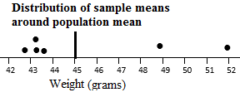  
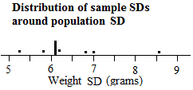

Extended answer results: ___ / 60

TOTAL test results: ___ / 109